Immigration and Citizenship

- Immigration QR Code for Android Devices 1. Citizenship QR Code for Android Devices
- Open BrainPop App on iPad 2. Open BrainPop App on iPad
- User ID: sae6 Password: movie 3. Search for Immigration, Click Citizenship
- Search for Immigration, Click Immigration 4. PC: www.brainpop.com/socialstudies/usgovernmentandlaw/citizenship/
- PC – Go to: www.brainpop.com/socialstudies/culture/immigration/
- Ellis Island QR Code for Android Devices 1. Ellis Island QR Code for PBS Kids Go!
- Open BrainPop Jr. App on iPad 2. Spend some time learning about our History.
- User ID: sae6 Password: movie 3. PC – Go to: http://pbskids.org/bigapplehistory/immigration/topic9.html
- Search for Ellis Island, Click Citizenship
- PC – Go to: http://www.brainpopjr.com/socialstudies/americanhistory/ellisisland/

Please complete the attached worksheets to gain a greater understanding of your personal heritage and the vocabulary involving immigration. Complete worksheet #2 in class and the Further Research Questions on Worksheet #3 in class as well using Safari on the iPad. Complete the remaining questions on Worksheet #3 at home tonight for homework.
Lastly, please take the practice test on Citizenship 2012 (found in the Social Studies Folder on the iPad) to see if you qualify to become a US Citizen…

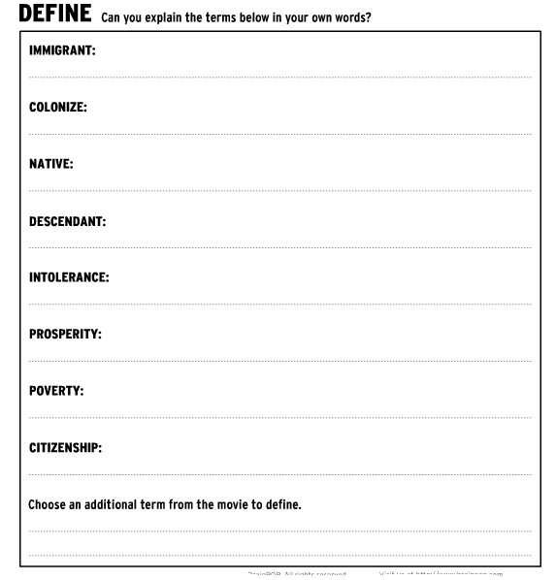
Please complete this worksheet at home to help you gain a greater understanding of your own personal heritage/origin.
